Assignment 1

**Q2.** Compare the numerical values returned by casadi_c2d with the results of the analytically discretized model - are they the same?

The numerical values returned from casadi_c2d correspond to the matrices:

and

The numerical values from analytically derived model in exercise 13 c gives the following matrices:

and

The A matrices is the same for both cases, but the B matrices are different. This is due to the transition from continuous to discrete. The B matrix doesn’t affect the A matrix during the transition, although the B matrices affect itself. See the equations below:

and

**Q3.** How many poles and zeros does the system have? Where are they located? How many poles and zeros do you expect for the discrete-time model, and where should they be located? Was your intuition right?

The continuous system has two poles at origin, i.e. 0 and no zeros. Our intuition was poles at 0 since matrix A’s characteristic polynomial will be lambda^2 = 0 and 0 is the only pole that will fulfill the requirement. See figure 1 below

Figure 1 - Poles for continuous system

Regarding the discrete system we expected 2 poles at 1. Which is fulfilled. See the figure 2 below.

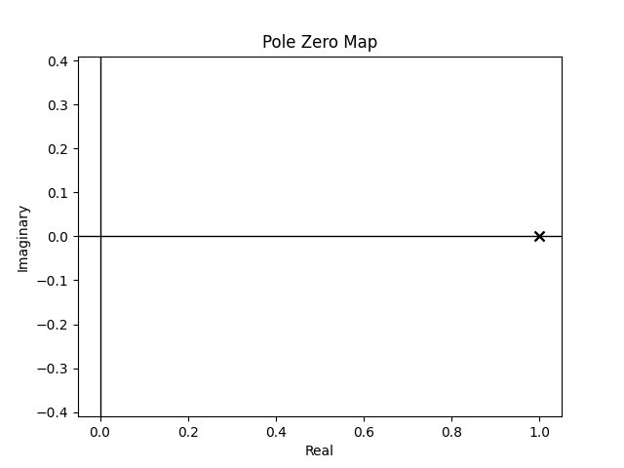

Figure 2 - poles for discrete system

**Q4.** If the control gain for the state feedback controller is designed with the two desired poles at and the requirements , and , see figure 3.

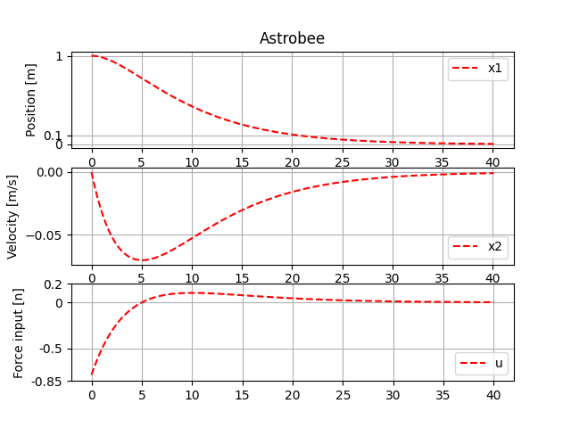

Figure 3: Control of the astrobee - Linear control without disturbance and without feedback

Including disturbances, the terminal condition couldn’t be reached, see picture 4.

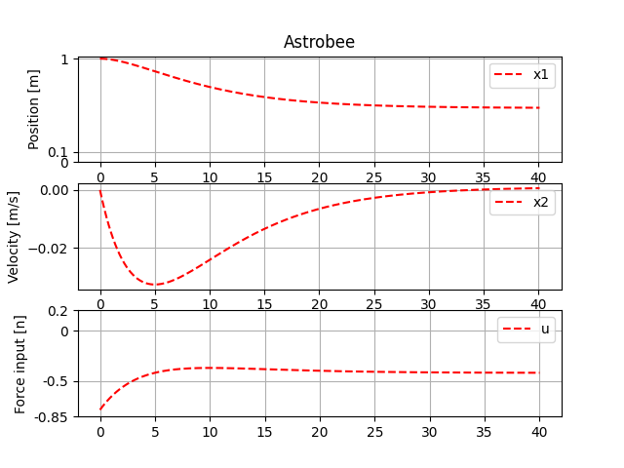

Figure 4: Control of the astrobee - Linear control with disturbance and without feedback

**Q5.** Design of Feedback loop with integral part needed to deal with disturbances. For reaching the requirement 90 % within 30 seconds, the Linear feedback gain is to be manipulated to accelerate the control with desired poles and for calculation. By implementing the integral state feedback with an integral gain the disturbance is controlled without overshooting, see figure 5.

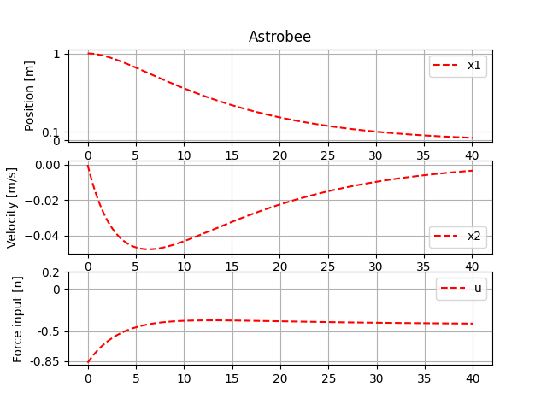

Figure 5: Control of Astrobee – Linear control, with disturbance and integral feedback control implemented